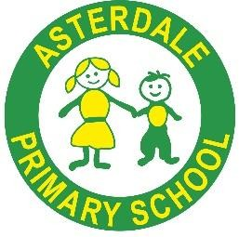

Asterdale Primary School Relationship, Sex & Health Education Policy

*‘Together We Can…’*

*Be confident, Be excellent, Nurture, Build*

|  |  |
| --- | --- |
| Written by: | John O’Leary |
| Approved by: | Mr John O’Leary, Acting Headteacher |
| Date Approved: | 17/10/ 2024 |
| Date of Review: | October 2027 |
| Version: | 1 |

We as a school consider our equality duties under the Equality act 2010. The general duties are to: -

* Eliminate discrimination
* Advance equality of opportunity
* Foster good relations

This policy understands the principle of the Act and the work needed to ensure that those with protected characteristics are not discriminated against and are given equality of opportunity

**Scope**

Safeguarding our children is of paramount importance to us at Asterdale Primary School.  
We also believe it is essential that children are provided with age-appropriate information to assist them in making sensible choices and developing respect for themselves and others as they progress through the school.  
   
Relationships and sex education is learning about the emotional, social and physical aspects of growing up, relationships, sex and human sexuality.  
   
As a school we have use a scheme of work called Jigsaw ([**www.jigsawpshe.com**](https://www.jigsawpshe.com/)) which is a comprehensive programme of PSHE (including RSE) which provides accurate information about the body, puberty and reproduction. It also gives children and young people essential skills for building positive, enjoyable, respectful and non-exploitative relationships and staying safe both on and offline.  
   
During the school year we will offer drop-in sessions for parents if they would like more clarity about what the children will be learning and to answer any questions that they may have. This allows home and school to work together to support our children.

**Aims**

The aims of relationships and sex education (RSE) within our school are to:

* Provide a framework in which sensitive discussions can take place

* Prepare pupils for puberty, and give them an understanding of sexual development and the importance of health and hygiene

* Help pupils develop feelings of self-respect, confidence and empathy
* Create a positive culture around issues of sexuality and relationships
* Teach pupils the correct vocabulary to describe themselves and their bodies
* Support character development to prepare young people for the future

**Statutory requirements**

At our school we must provide relationships education to all pupils as per section 34 of the Children and Social work act 2017.

We are expected to offer all pupils a curriculum that includes requirements to teach science which would include the elements of sex education contained in the science curriculum.

In teaching RSE, we are required by our funding agreements to have regard to guidance issued by the secretary of state as outlined in section 403 of the Education Act 1996.

At our school we teach RSE as set out in this policy.

In teaching RSE, we are required to have regard to guidance issued by the secretary of state as outlined in section 403 of the Education Act 1996.

**Definition**

RSE is about the emotional, social and cultural development of pupils, and involves learning about positive relationships, sexual health, sexuality, healthy lifestyles, diversity and personal identity at developmentally appropriate levels across the different year groups.

RSE involves a combination of sharing information, and exploring issues and values in a safe and inclusive environment. RSE is not about the promotion of sexual activity.

**Curriculum**

Our curriculum is set out as per Appendix 1 but we adapt it as and when necessary.

We have developed the curriculum in consultation with parents, pupils and staff, taking into account the age, developmental needs and feelings of pupils. If pupils ask questions outside the scope of this policy, teachers will respond in an appropriate manner so they are fully informed and don’t seek answers online.

**Primary** sex education will focus on:

* Preparing boys and girls for the changes that adolescence brings (beyond the factual and anatomical teaching of puberty and the human body covered in the science curriculum) ∙
* How a baby is conceived and born

For more information about our curriculum, see our curriculum map in Appendix 1.

**Delivery of RSE**

At Asterdale Primary School, RSE is taught within the context of family life taking care to ensure that there is no stigmatisation of children based on their home circumstances with the recognition that families may take many different forms. We help our children to reflect sensitively that some may have a different structure of support around them. Providing opportunities to build their character.

High quality resources support our RSE provision and delivery. These are reviewed regularly and enable the RSE curriculum to be embedded across all areas of the curriculum as an integral part of daily school life.

Biological aspects of RSE are taught within the science curriculum, and other aspects are included in religious education (RE).

At ourschool relationships education focuses on teaching the fundamental building blocks and characteristics of positive relationships including:

* Families and people who care for me
* Caring friendships
* Respectful relationships
* Online relationships
* Being safe

The following statements outline what is covered within ourRSE curriculum in addition to the statutory science curriculum:

* Preparing boys and girls for the changes that adolescence brings (beyond the factual and anatomical teaching of puberty and the human body covered in the science curriculum) ∙
* How a baby is conceived and born

For more information about our RSE curriculum, see Appendices 1 and 2.

**Pupils with Special Education Needs and Disabilities (SEND)**

RSE is accessible for all pupils. We recognise the importance of planning teaching for pupils with special educational needs and disabilities. High quality teaching that is differentiated or personalised will be the starting point to ensure accessibility.

We recognise that some pupils are more vulnerable to exploitation, bullying and other issues due to the nature of their SEND. RSE can also be particularly important subjects for some pupils; for example, those with Social, Emotional and Mental Health needs or learning disabilities.

**Equality**

Under the provisions of the Equality Act 2010, schools must not unlawfully discriminate against pupils because of their age, sex, race, disability, religion or belief, gender reassignment, pregnancy or maternity, marriage or civil partnership or sexual orientation (collectively known as the protected characteristics).

We are able to make reasonable adjustments to alleviate disadvantage and are aligned with the SEND Code of Practice Standards when planning for these subjects.

**The Governing Body**

Local Governing Bodies will monitor the ongoing implementation of this policy.

**The Headteacher**

Headteachers are responsible for managing requests, where appropriate, to withdraw pupils from non-statutory components of RSE (see section 8).

**Staff**

All staff in school are responsible for:

* Delivering RSE in a sensitive way
* Modelling positive attitudes to RSE
* Monitoring progress
* Responding to the needs of individual pupils
* Responding appropriately to pupils whose parents wish them to be withdrawn from the non - statutory components of RSE

Staff who have concerns about teaching RSE are encouraged to discuss this with PSHE/RSE lead and the headteacher.

**The PSHE/RSE Lead**

The PSHE/RSE lead is responsible for

* ensuring that RSE is taught consistently in school
* Leading the staff team in teaching RSE in an appropriate manner
* Supporting/coaching staff members to teach RSE
* Responding to parental concerns with regard to RSE

**Pupils**

Pupils are expected to engage fully in RSE and, when discussing issues related to RSE, treat others with respect and sensitivity, with regard to the JIGSAW charter.

**Parents’ right to withdraw**

Parents do not have the right to withdraw their children from relationships education.

Parents do have the right to withdraw their children from the non-statutory components of sex education within RSE as outlined below and in appendix 1.

* Preparing boys and girls for the changes that adolescence brings (beyond the factual and anatomical teaching of puberty and the human body covered in the science curriculum).
* How a baby is conceived and born.

Requests for withdrawal should be put in writing and addressed to the headteacher of school – Mr John O’Leary.

A copy of withdrawal requests will be placed in the pupil’s educational record. The headteacher will discuss the request with parents and take appropriate action.

**Assessment and Monitoring**

The delivery of RSE is monitored through systems including (but not limited to):

* Book monitoring
* learning walks
* pupil voice discussions

Pupils’ development in RSE is monitored as part of our internal assessment systems and are used to ensure all pupils gain a sound knowledge of all curriculum areas. Appropriate support and intervention is put in place as needed.

**Appendix 1: Curriculum map**

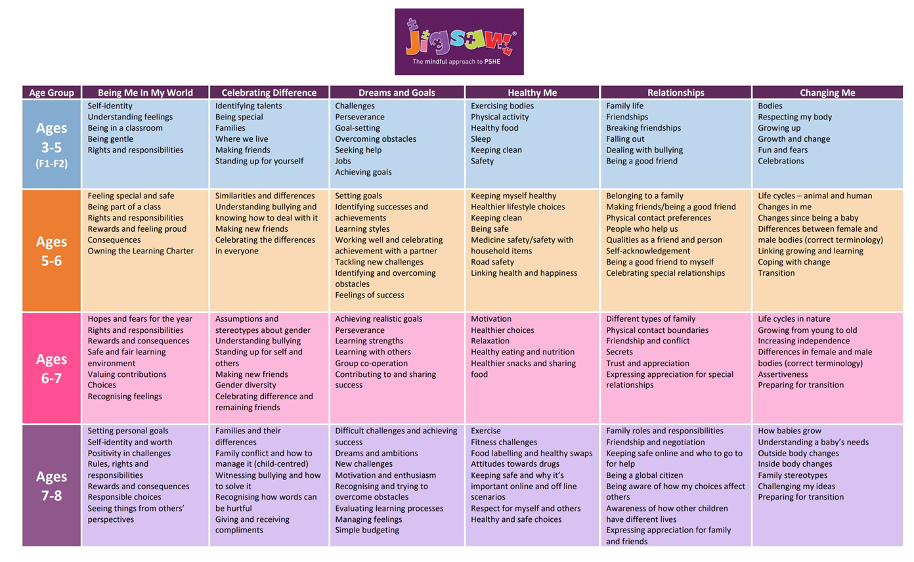

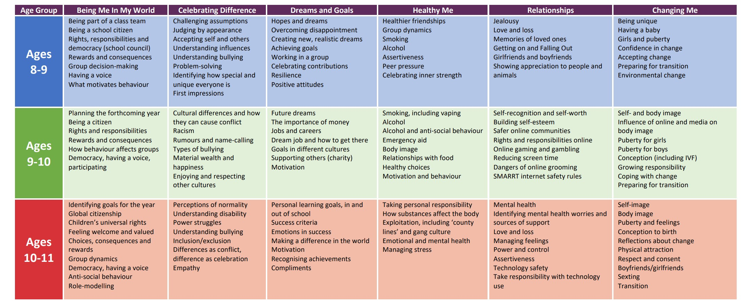

**Appendix 2: By the end of primary school pupils should know**

|  |  |
| --- | --- |
| Topic | Pupils should know |
| Families and people who  care about me | * That families are important for children growing up because they can give love, security and stability * The characteristics of healthy family life, commitment to each other, including in times of difficulty, protection and care for children and other family members, the importance of spending time together and sharing each other’s lives * That others’ families, either in school or in the wider world, sometimes look different from their family, but that they should respect those differences and know that other children’s families are also characterised by love and care * That stable, caring relationships, which may be of different types, are at the heart of happy families, and are important for children’s security as they grow up * That marriage represents a formal and legally recognised commitment of two people to each other which is intended to be lifelong * How to recognise if family relationships are making them feel unhappy or unsafe, and how to seek help or advice |
| Caring friendships | * How important friendships are in making us feel happy and secure, and how people choose and make friends * The characteristics of friendships, including mutual respect, truthfulness, Trustworthiness, loyalty, kindness, generosity, Trust, sharing interests and experiences and support with problems and difficulties * That healthy friendships are positive and welcoming towards others, and do not make others feel lonely or excluded * That most friendships have ups and downs, and that these can often be worked through so that the friendship is repaired or even strengthened, and that resorting to violence is never right * How to recognise who to trust and who not to trust, how to judge when a friendship is making them feel unhappy or uncomfortable, managing conflict, how to manage these situations and how to seek help or advice from others, if needed |
| Respectful relationships | * The importance of respecting others, even when they are very different from them (for example, physically, in character, personality or backgrounds), or make different choices or have different preferences or beliefs * Practical steps they can take in a range of different contexts to improve or support respectful relationships * The conventions of courtesy and manners * The importance of self-respect and how this links to their own happiness |

|  |  |
| --- | --- |
|  | * That in school and in wider society they can expect to be treated with respect by others, and that in turn they should show due respect to others, including those in positions of authority * About different types of bullying (including cyberbullying), the impact of bullying, responsibilities of bystanders (primarily reporting bullying to an adult) and how to get help * What a stereotype is, and how stereotypes can be unfair, negative or destructive * The importance of permission-seeking and giving in relationships with friends, peers and adults |
| Online relationships | * That people sometimes behave differently online, including by pretending to be someone they are not * That the same principles apply to online relationships as to face-to face relationships, including the importance of respect for others online including when we are anonymous * The rules and principles for keeping safe online, how to recognise risks, harmful content and contact, and how to report them * How to critically consider their online friendships and sources of information including awareness of the risks associated with people they have never met * How information and data is shared and used online |
| Being safe | * What sorts of boundaries are appropriate in friendships with peers and others (including in a digital context) * About the concept of privacy and the implications of it for both children and adults; including that it is not always right to keep secrets if they relate to being safe * That each person’s body belongs to them, and the differences between appropriate and inappropriate or unsafe physical, and other, contact ∙ How to respond safely and appropriately to adults they may encounter (in all contexts, including online) whom they do not know * How to recognise and report feelings of being unsafe or feeling bad about any adult * How to ask for advice or help for themselves or others, and to keep trying until they are heard * How to report concerns or abuse, and the vocabulary and confidence needed to do so * Where to get advice e.g. family, school and/or other sources |